Division(s): N/A

ITEM PF8E

PENSION FUND COMMITTEE - 26 MAY 2006

OVERVIEW AND OUTLOOK FOR INVESTMENT MARKETS

Report by the Independent Financial Adviser

- Six months ago the consensus expectation was that the global economy would experience a usual mid-term cyclical slowdown in the second half of this year and into 2007, but this has now been replaced by renewed optimism as exemplified by the latest IMF forecasts for growth for 2006

UK 2.5%
USA 3.4%
Eurozone 2.0%
Japan 2.8%

- Such wild swings in consensus expectations help explain why actual growth is not often in line with consensus forecasts. However, some astute observers are still looking for the usual mid-cycle correction with growth this year of only 2.4% in the USA, 1.3% in the Eurozone and nearer 2.0% in the UK, in spite of a firm first quarter. The high levels of personal debt in western economies with the need to rebuild personal balance sheets, coupled with the rising cost of mortgages in the USA, are expected to reduce the growth in consumption. This is already happening in the UK where retail sales volumes fell by 0.7% in the first quarter of 2006, compared with the previous quarter and growth in the service sector, which represents three quarters of the economy, in the first quarter was only 0.6%, its weakest for more than a year. In contrast, Japan is expected to maintain its momentum, as is China with growth of around 9% and the rest of Asia also with strong growth.

- The rise in interest rates in the USA and the Eurozone will have their usual delayed impact on economic growth. The US is near the end of its cycle of lifting interest rates, which have been increased by ¼% steps from 1% at each Fed. meeting since June 2004. Further increases beyond the current level of 5% could still take place over the coming months. While in the Eurozone interest rates have been lifted from 2% in December 2005 to the current 2½%, and the market is expecting them to reach 3% to 3¼% by early next year. In the UK the next move in rates could well be an increase from the current level of 4½%. Further the recent rise in the oil price above US$70 is an additional factor depressing growth in developed countries as it transfers purchasing power to the producing nations, which are normally slow to spend it.

- In the meantime, six months ago central banks started draining liquidity from the system and this trend was recently reinforced when the Bank of Japan ended its policy of flooding the domestic market with money to prevent deflation taking hold. This liquidity found its way to other world markets, partly through the ‘carry trade’, whereby hedge funds and other institutions borrow in low interest rate markets to invest in other markets and this has helped to drive financial asset prices sharply upwards. The Bank of Japan is now withdrawing this liquidity rapidly.

Markets

- In spite of the negatives mentioned above the UK equity market has risen sharply by 20% since the last correction in October 2005, driven by ample liquidity, which central banks are now withdrawing. As expected the market is encountering difficulty in breaking effectively through the 6000 level on the FTSE100 or 3000 on the All Share Index, because of the huge concentration of dealings in that area before the bear market of 2001-2003. The return of the private investor in force (see charts below) and the plethora of bids could be further signs that a temporary top has been reached and that the market is due for a correction.

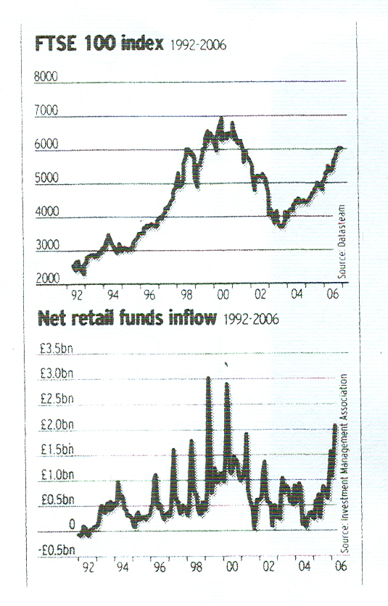

- No market goes up in a straight line. Nevertheless the market is not expensive on a prospective 2006 price/earnings (PE) ratio of 14½ and company earnings and balance sheets are strong. After a correction the market could be higher before the end of the year, subject to no major unforeseen event such as escalating trouble in the Middle East. A correction is similarly due in European equity markets. The US market is at an interesting position. It has only risen 10% from the October lows and so is not so over extended as the UK and European markets, and it is currently testing the highs of the previous bull market of 2000 and 2001. The prospective PE is 15½, which is not overly expensive, and profit growth is strong. If the US market did break effectively into new high ground, it would limit any correction in UK and European markets or turn them into consolidations. The Japanese market is currently consolidating, but with continuing strong profit growth it could move ahead again later.

- Bond yields, which particularly in the UK had been driven down to unjustifiably low levels principally by pension fund purchases of long dated issues to match liabilities, have since February 2006 risen modestly.

UK Government Bonds (‘Gilts’)
Yield | September 2005 | February 2006 | May 2006
 | % | % | %
Benchmark 10 year | 4.3 | 4.1 | 4.7
4¼% Treasury 2055 | 4.1 | 3.7 | 4.1
Less inflation at say RPI | 2.7 | 2.7 | 2.7
Real Yield | 1.4 | 1.0 | 1.4
Treasury Index Linked Bonds 2055 | 1.1 | 0.5 | 1.0

- On the basis that money in non-inflationary conditions is expected to earn about 2.5%, real yields are still too low. Moreover they are low compared with overseas with the yield on 2% UK index linked 2035 at 1.2% against US index linked 3.625% 2028 at 2.5%.The UK equity market on 2.9% or even cash at 4.5% are better investments. In the medium term yields must move higher and this will result in substantial capital losses for holders.
- Strong demand for base metals from developing countries, particularly China and India, together with steady growth in developed countries, have ended a multi-year bear market and pushed prices higher.

- However, since the beginning of 2006 ample global monetary liquidity has enabled hedge funds and other short term operators to take positions unrelated to underlying demand, causing a sharp upward spike in prices, as the following charts show the movements.

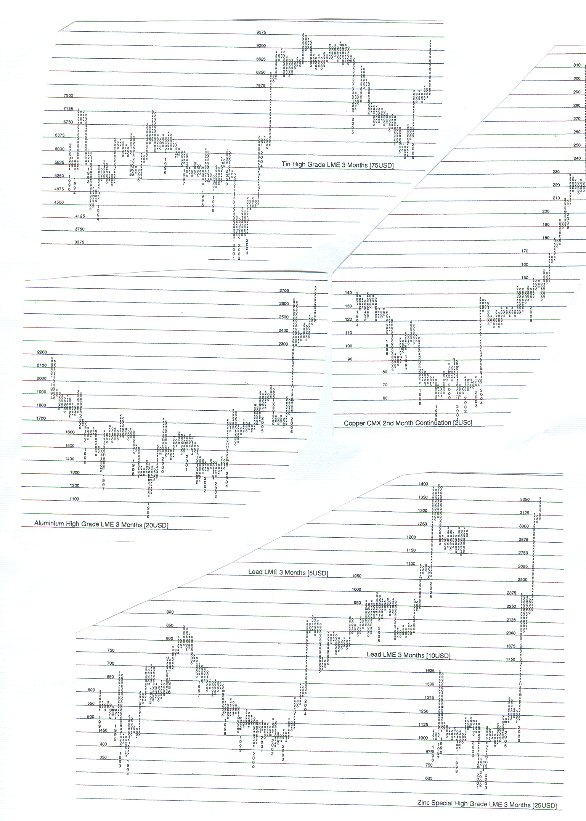

- The markets in most base metals are now due for a correction, which, because of the steepness of the rise in prices, could be severe and could be caused by the delayed effect of central banks increasing interest rates and draining liquidity from the system.

- Currency exchange rates have been steady over most of the period, but just recently the US dollar has started to weaken. This is probably because the Fed. is near the end of its cycle of increasing interest rates, while Eurozone rates will probably have proportionately further to rise and Japan will probably only start lifting rates much later this year after years of zero rates. Thus the US dollar has weakened against the euro from $1.21 to $1.28 and against the Japanese Yen from Yen 118 to Yen 110. The US dollar has also weakened against sterling from $1.74 to $1.86. The US dollar’s weak trend will probably continue.

Charts of stock markets and currencies are attached.

A F Bushell
Independent Financial Adviser

May 2006


